FOOD MANAGEMENT SYSTEM

**Use-Case Specification: Editing Product**

Version <1.0>

Revision History

|  |  |  |  |
| --- | --- | --- | --- |
| **Date** | **Version** | **Description** | **Author** |
| <7/12/2020> | <1.0> | <details> | <Nguyen Thu Trang> |

Table of Contents

1. Use-Case Name 4

1.1 Brief Description 4

2. Flow of Events 4

2.1 Basic flow 4

2.2 Alternative flow 4

2.2.1 <First Alternative flow> 4

2.2.1 <Second Alternative flow> 4

3. Special Requirement 4

3.1 <First Special Requirement> 4

4. Preconditions 4

4.1 <Precondition One> 4

5. Posstcondition 4

5.1 <Postcondition One> 4

6. Extension Points 5

6.1 < Name of Extension Points> 5

Use-Case Specification: Editing Product

1. **Editing product**
   1. **Brief Description**

This use case defines the step of editing products. The system allow admin to edit information involved to product.

* 1. **Actor**

Admin.

1. **Flow of Events**
   1. **Basic Flow**

First, admin click on manage product button. The system display  product view. Admin will input information about new product (id, name, price, brand, etc) need to be edited. Admin click on Save to confirm change. After, system will update product information

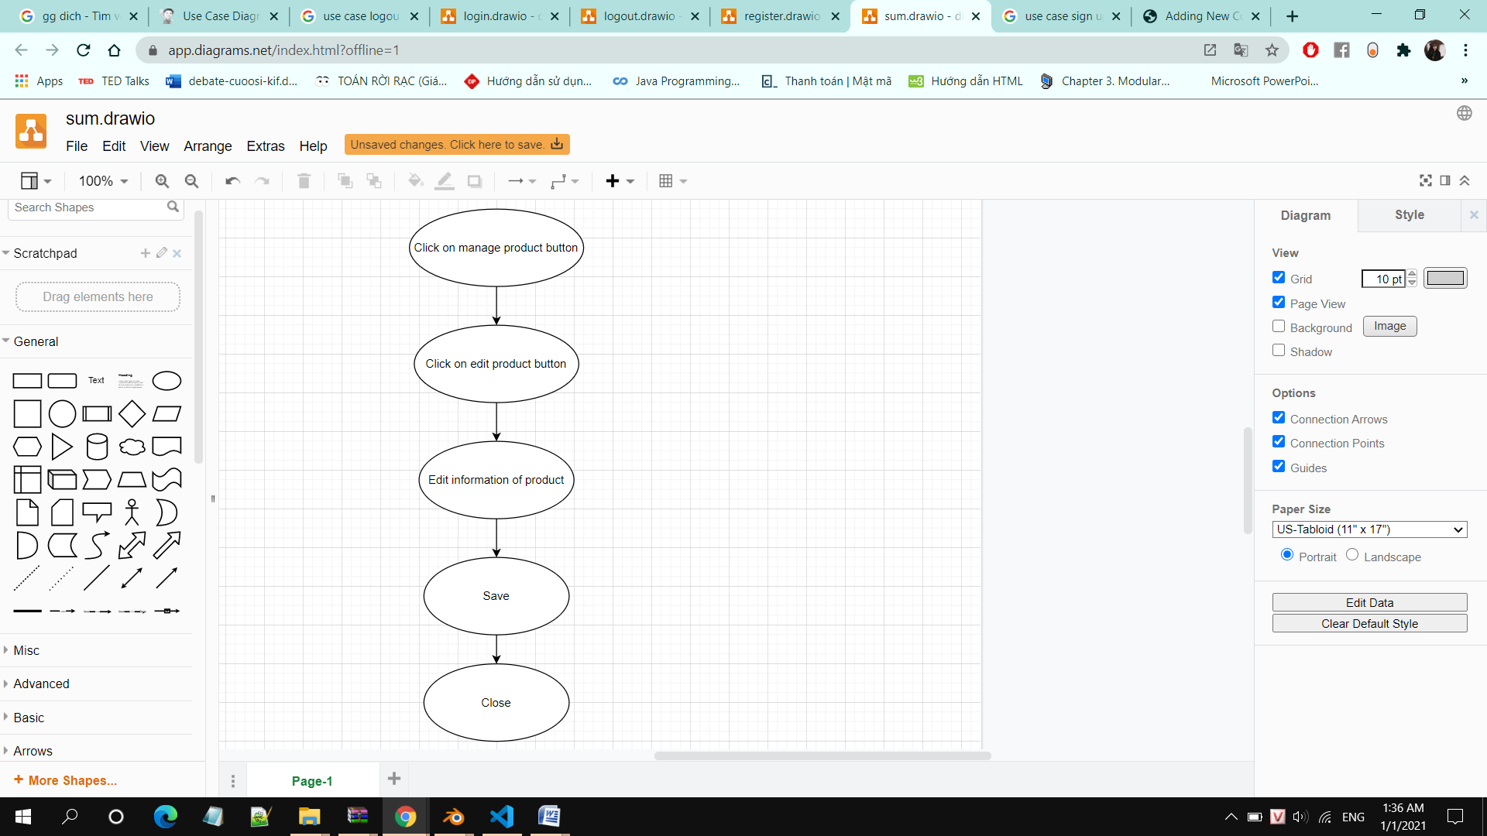

1. **Special Requirements**

Admin must know how to use the product management system.

1. **Preconditions**

Admin must have information of the product (Name, Price, image, etc)

1. **Postconditions**

No postconditions.

1. **Extension Points**

No extension points.